FOR IMMEDIATE RELEASE

Contact: Kelly Winkler Shannon DePaul
Alpha Dog Advertising Alpha Dog Advertising
717.517.9944 x107 717.517.9944 x104
kwinkler@alphadogadv.com sdepaul@alphadogadv.com

Construction Specialties Unveils Its Exclusive
CSelect™ Fabric for Cubicle Curtains
The new proprietary curtain fabric collection is part of a design system that provides a wide array of aesthetic options for commercial interior designers

(LEBANON, NJ) — November 10, 2020 — Construction Specialties (CS), a leading manufacturer of commercial building products, has designed its first exclusive fabric line — CSelect™ fabrics. Inspired by a healthcare industry and a design community looking for calming, stress-free environments, the CSelect fabric line, exclusive to CS, brings the outside in, evoking tranquility yet delivering a re-energizing feel to a space.

Inspired by Nature. Looks like Home.
The CSelect fabrics’ material heft and stitching detail brings a high-end, home-inspired design aesthetic to a commercial space. This designer-centric curtain fabric solution embodies soft and vibrant hues that reflect the earth’s natural elements — helping create calm, healing environments with a home vibe.

Perfect for healthcare, hospitality, and education building segments, and with applications for patient rooms, emergency rooms, and senior living, CSelect fabrics bring an air of sophistication and a calming, nature-inspired design to what is customarily a colorless and sterile space. Employing the exclusive designs of the CSelect fabric line provides a blueprint for a space that demands a warmer and calmer environment, but also requires a private setting for healing and intimate health discussions with medical staff and family.

-more-

Create 24 Unique Design Combinations
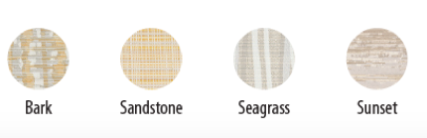
Indulge in the warming allure of CSelect fabrics’ wide selection of nature-inspired colors and patterns, from tones of tranquil blues and coppers to soft reds and pops of serene greens and yellows. With four pattern options and six colorways for a total of twenty-four combinations, providing privacy protection has never looked so good.
Patterns

Sample Combinations
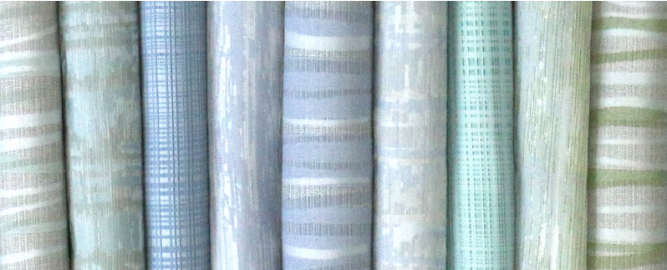

The CSelect fabric line is part of a larger system of interior products intended to seamlessly work together. For example, CSelect fabrics are designed to coordinate with the Acrovyn by Design® Tapestry™ Collection — a line of protective wall coverings, also inspired by nature’s own textures and colors.

From the hallway leading to the exam room, to the head wall, to the privacy curtains, Construction Specialties continues to build out their coordinated interior products to create the tools designers are looking for to create uninterrupted connectivity in their design.

“In designing our own fabric collection, we are accomplishing a number of things, including expanding our offerings and connecting new offerings with existing interior products,” said Kevin Fitzpatrick, Director, Industrial Design, Construction Specialties. “We recently brought on a product designer to work on new lines like CSelect, and with our commitment to a refresh frequency mindset, we will periodically look to our color offerings, woodgrains, and other decorative elements in order to keep in line with market design trends.”

-more-

CSelect fabrics can be used with the HUSH Curtain®, On the Right Track®, Snap Lock, standard track systems, and shower curtains with liners. All of the curtain fabrics come with the option to treat the fabric with a blend of Nanotex® + bioAM® for added protection against microorganisms.

Coordinating Disposable Curtains Coming Soon
Whereas the CSelect fabric is intended for more permanent installations, its coordinating disposable paper curtains can be used for easy and fast changeovers in patient areas undergoing cleaning. The disposable versions will offer complementary colors — second cousins, if you will — to the CSelect fabrics, providing designers with color options far beyond the standard surgical blue and beige. The CSelect disposables will be available this coming early 2021.

For more information about the exclusive CSelect Curtain fabric line, visit here.

For high-res images, please visit here.
About Construction Specialties
Founded in 1948, Construction Specialties (CS) is a family-owned building products manufacturer that provides solutions to challenges that architects, designers, contractors, building owners, and facility managers face every day. Since inventing the first extruded louver, CS has become a global leader in Acrovyn® interior wall protection; impact-resistant doors; entrance flooring, including GridLine®; expansion joint covers; architectural louvers and grilles; sun controls; explosion and pressure relief vents; and cubicle curtains and tracks. Drawing upon extensive expertise to provide standard and custom, high-quality products — many of which are Cradle to Cradle CertifiedTM — CS products can be found in some of the world’s most significant architecture. For more information about CS products and solutions, please visit www.c-sgroup.com.

